**Title of the article should be no more than 16 words**

*Author 1 Name1, Author 2 Name2, Author 3 Name3*

1 Affiliation Author ; 2 Affiliation Author; 3 Affiliation Author

Email ID

**Abstract:** No more than 200 words, if the article is original then the abstract should be framed in the following order (a) Problem statement/motivation of the article (b) solution ( c) significant findings (d) applications

**Keywords**: Keyword 1; keyword 2; keyword 3; Keyword 4; keyword5

Example:

**Abstract**: The Southwest shrub Juniperus communis (Juniper Berry) has many significant medicinal value in the Native American culture that has not been proven scientifically. One of the popular uses of Juniper berries aside from its detoxifying action is its potential to repel insects. This study focuses on the development of insect repellant from its essential oil obtained through steam distillation. 50 g of fresh berries was collected and dried for 5 days and is placed in a still tank with 100 mL of water for steam distillation using the Flinn Scientific Borosilicate Lab Kit. Gather the extracted oil and dilute 70% in three separate containers to be transferred into spray bottles. Testing involved the spraying of the dilute sample into a class jar with Anopheles juidthae (common NM mosquito) and compared this to the effect of a commercial insect repellant. After testing and comparing the result, the commercial insect repellant significantly showed that it is a better insect repellant compared to the J. communis diluted essential oil. However, the essential oil has also an insect repellant potential.

**Keywords**: Oils; Insect Repellent; Juniper; Mosquito; Malaria.

**Introduction**

The introduction should set the tone of the article and provide the reader with a good understanding of the problem statement. Please keep in mind that the problem statement should match the Abstract’s motivation/problem statement[1].

**Related work**

You should introduce the reader to similar works done by other researchers. In this section, it is always a good practice to provide a brief history on related work and then introduce the latest works mentioned [1-3]. If possible Try to tabularize the data and compare all the previous works[1]. The table 1 tabularizes as an example. Always cite the references in the main text in square brackets [1]. The references should be formatted as per the standard IEEE guidelines.

**Table 1. Compares this work with the related work or previous research by other researchers**

|  |  |  |  |
| --- | --- | --- | --- |
|  | Parameter 1 | Parameter 2 | Parameter 3 |
| [1] | No | Yes | No |
| [2] | Yes | No | No |
| [3] | Yes | Yes | No |
| This work | Yes | NO | Yes |

**Key Contribution**

This is the section in which you should introduce the readers to the key contributions your paper has made. While it is always good to have novelty, however, for proceedings the novelty is not the primary criterion. The criterion in proceedings is how you are adding additional information to the existing body of knowledge. Eg. Your observations may be original.

**Method, Experiments and Results**

Discuss the methods/experiments you conducted and the results obtained in a systematic and detailed way.Use of good figures is encouraged. The figure example is given below. Please ensure to mention the figure or describe the figure. E.g. Figure 1 shows how a figure should be in a good manuscript, the fontsize of the text in the figure should be at least as big as the figure caption in the main body of the article.

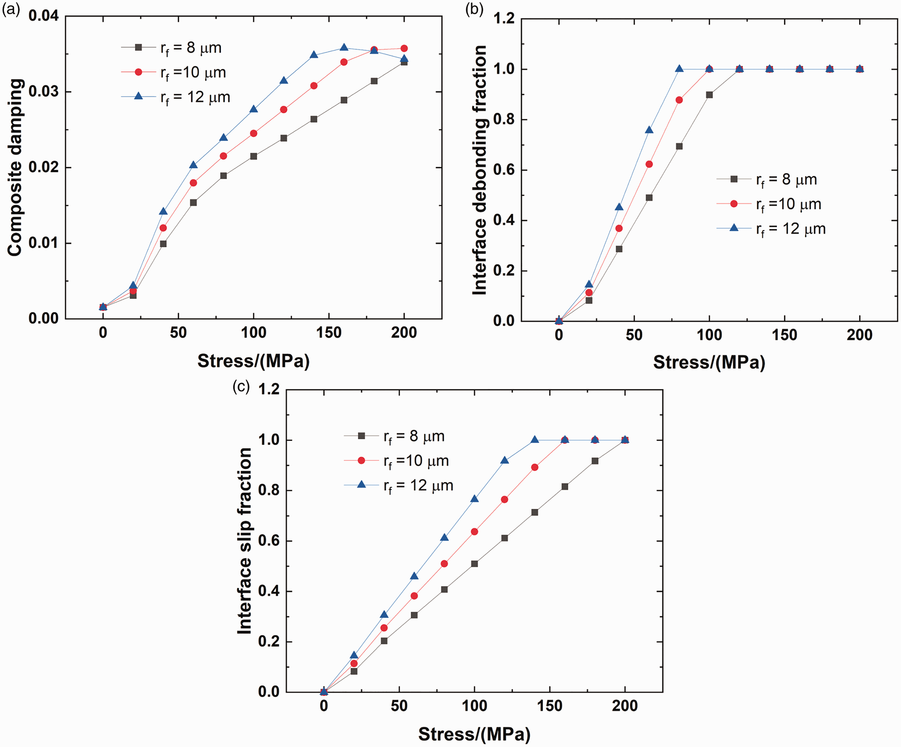

***Figure 1. The size of the font in the figures should be equivalent to the size of this text that you are reading.***

**Discussions**

Discussions should be carried out in the article for the readers to understand the meaning of your results and experimental findings

**Conclusions**

Provide a pointwise conclusions on the following lines:

1. Problem statement Addressed/ Motivation
2. Method used
3. Key findings
4. Limitations of the work and future work that should be carried

Please note- Not all articles will have similar conclusions mentioned as above. Review articles differ in the way they are written.

**References**

1. X. Zhang, X. Zhang and L. Han, "An energy efficient Internet of Things network using restart artificial bee colony and wireless power transfer", *IEEE Access*, vol. 7, pp. 12686-12695, 2019.

<https://doi.org/10.1109/ACCESS.2019.2892798>

1. X. Zhong, L. Zhang and Y. Wei, "Dynamic load-balancing vertical control for a large-scale software-defined Internet of Things", *IEEE Access*, vol. 7, pp. 140769-140780, 2019.

<https://doi.org/10.1109/ACCESS.2019.2943173>

1. M. Malik, M. Dutta and J. Granjal, "A survey of key bootstrapping protocols based on public key cryptography in the Internet of Things", *IEEE Access*, vol. 7, pp. 27443-27464, 2019.

<https://doi.org/10.1109/ACCESS.2019.2900957>